CSCI 3901

**Software Development Concepts**



Faculty of Computer Science

**Lab 7: “MYSQL Connection”**

Kishan Kahodariya B00864907

Dhruv Patel B00868931

**Part - 01**

**Use the command “show tables**

* Following table is the output of show tables:

|  |
| --- |
| **# Tables_in_csci3901** |
| 'MamiCustomers' |
| 'categories' |
| 'customercustomerdemo' |
| 'customerdemographics' |
| 'customers' |
| 'employees' |
| 'employeeterritories' |
| 'orderdetails' |
| 'orders' |
| 'products' |
| 'region' |
| 'sample5' |
| 'sample6' |
| 'shippers' |
| 'suppliers' |

**Report the outcome of the following SQL statements:**

1. **Select * from orders where OrderID = 10260;**

|  |  |
| --- | --- |
| **OrderID** | 10260 |
| **CustomerID** | OTTIK |
| **EmployeeID** | 4 |
| **OrderDate** | 1996-07-16 |
| **RequiredDate** | 1996-08-16 |
| **ShippedDate** | 1996-07-29 |
| **ShipVia** | 1 |
| **Freight** | 55.0900 |
| **ShippName** | Ottilies Kseladen |
| **ShipAddress** | Mehrheimerstr. 369 |
| **ShipCity** | Kln |
| **ShipRegion** | Null |
| **ShipPostalCode** | 50739 |
| **ShipCountry** | Germany |

1. **Select * from orderdetails where OrderID = 10260;**

|  |  |  |  |  |
| --- | --- | --- | --- | --- |
| **OrderID** | **ProductID** | **UnitPrice** | **Quantity** | **Discount** |
| 10260 | 41 | 7.7000 | 16 | 0 |
| 10260 | 57 | 15.6000 | 50 | 0 |
| 10260 | 62 | 39.4000 | 15 | 0 |
| 10260 | 70 | 12.0000 | 21 | 0 |
|  |  |  |  |  |

**(c) Select ProductID, ProductName, CategoryID from products where ProductID = 41**

**or ProductID = 57;**

|  |  |  |
| --- | --- | --- |
| **ProductID** | **ProductName** | **CategoryID** |
| 41 | Jack's New England Clam Chowder | 8 |
| 57 | Ravioli Angelo | 5 |

**(d) Select customers.CustomerID, CompanyName from orders, customers where OrderID**

**= 10260 and orders.customerID = customers.CustomerID;**

|  |  |
| --- | --- |
| **CustomerID** | **CompanyName** |
| OTTIK | Ottilies Kseladen |

**Part 2 - Java connection**

**Create a program that will ask for an order number from the user and will show the order information on the screen as an invoice. The invoice should include:**

1. **The order date and order number**
2. **The customer name and address**
3. **The product codes and quantities ordered**
4. **The total cost of the order**

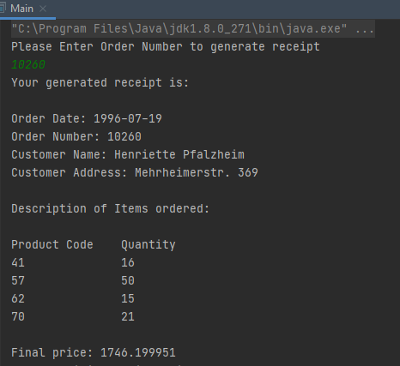

**Part – 03**

**Question**

**How could you test the correctness of your program from Part 2?**

* To check the correctness of the program in part 2, one can test every query called on the program in the MYSQL Workbench application and check if the output matches with the output of the program.